**DAILY ONLINE ACTIVITIES SUMMARY**

|  |  |  |  |
| --- | --- | --- | --- |
| **Date:** | 19/06/2020 | **Name:** | Krishnitha |
| **Sem & Sec** | 4th sem, A Section | **USN:** | 4AL18CS039 |
| **Online Test Summary** | | | |
| **Subject** | Microcontroller and Embedded System | | |
| **Max. Marks** | 20 | **Score** | 20 |
| **Certification Course Summary** | | | |
| **Course** | Application Developer | | |
| **Certificate Provider** | AWS Educate | **Duration:** | 3 hrs |
| **Coding Challenges** | | | |
| **Problem Statement:**  Write a C Program to Count total set bits in all numbers from 1 to n. | | | |
| **Status:** Executed | | | |
| **Uploaded the report in GitHub** | | YES | |
| **If yes Repository name** | | <https://github.com/krishnitha/C-coding> | |
| **Uploaded the report in slack** | | YES | |

**ONLINE TEST DETAILS:**

Today we had assessment in the Microcontroller and Embedded System. The test was conducted on the fourth module of this subject. The test contained 20 questions of one mark each, out of which I scored 20.

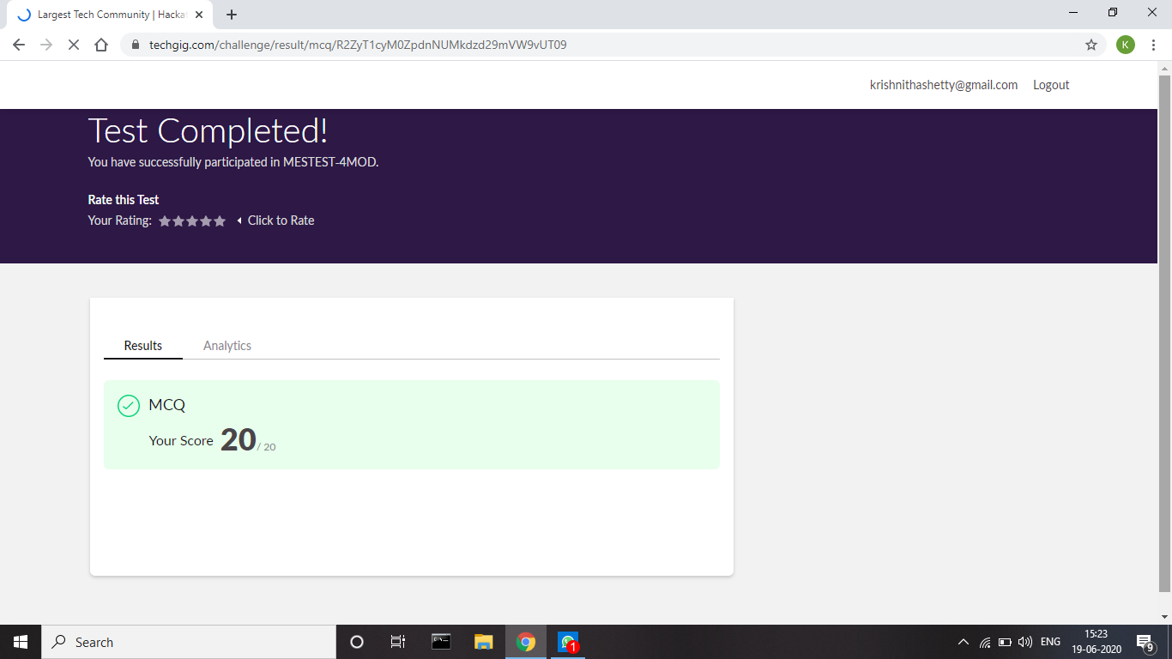

**Certification Course Details:**

Today I have continued the course “Application Developer” by AWS Educate. In this course today I learnt about the last chapter of Platforms module i.e. Platform visualization. And I have also completed the final assessment and final project of this course and I have earned a badge.

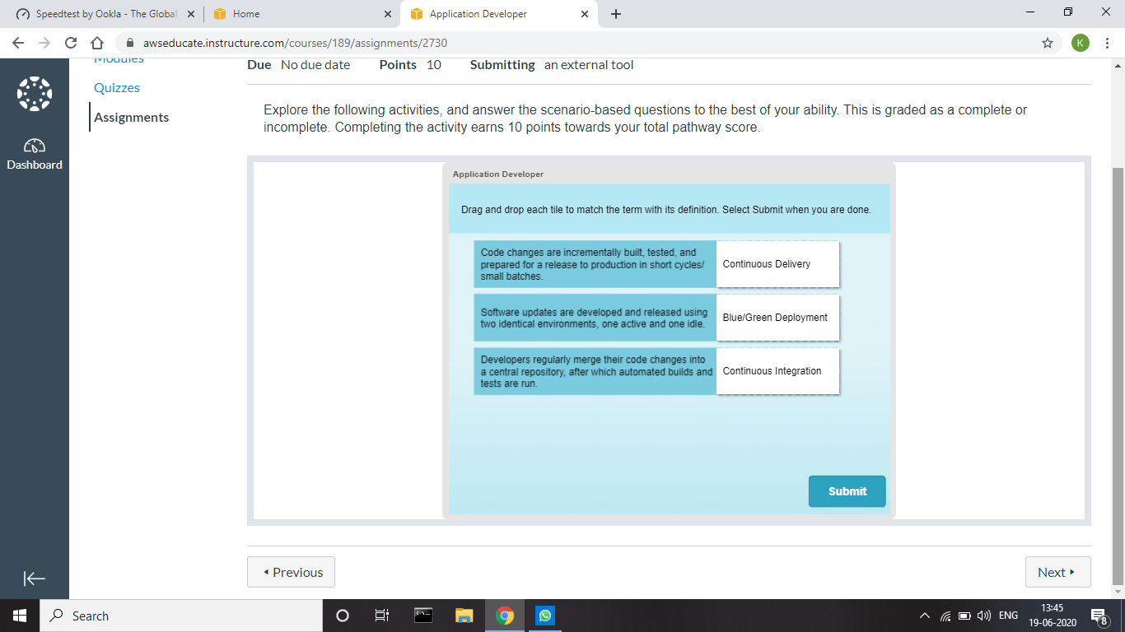



**Coding Challenges Details:**

**Problem:** Write a C Program to Count total set bits in all numbers from 1 to n.

Given a positive integer n, count the total number of set bits in binary representation of all numbers from 1 to n.

**Examples:**  
Input: n = 3  
Output: 4  
Input: n = 6  
Output: 9

**Hint:** Read a positive integer (example: 3 indicates range), so u have to consider 1, 2, 3 as the input convert these numbers into binary and count the number of 1 in that (1- 0001, 2- 0010, 3- 0011) number of 1s from all 3 digit is 4 so the answer is 4

**Solution:** Uploaded it in GitHub

